**Practical No 9**

**Practical of analysis of variance**

> y1=c(18.2,20.1,17.6,16.8,18.8,19.7,19.1)

> y2=c(17.4,18.7,19.1,16.4,15.9,18.4,17.7)

> y3=c(15.2,18.8,17.7,16.5,15.9,17.1,16.7)

**Now we are combining them into one long vector with a second vector,identifying group membership**

> z=c(y1,y2,y3)

> n=rep(7,3)

> n

[1] 7 7 7

> group=rep(1:3,n)

> group

[1] 1 1 1 1 1 1 1 2 2 2 2 2 2 2 3 3 3 3 3 3 3

**Here are summaries by group and for the combined data,first we show steam-leaf diagrams**

> tmp=tapply(z,group,stem)

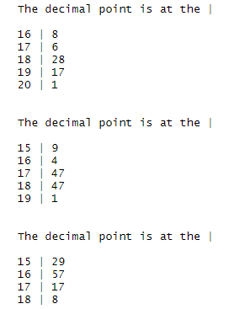

> stem(z)

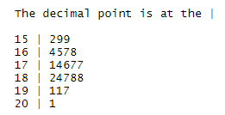

**Now we show summary statistics by group and overall.we locally define a temporary funvction tmpfn to make this easier**

> tmpfn=function(x)c(sum=sum(x),mean=mean(x),var=var(x),n=length(x))

> tapply(z,group,tmpfn)

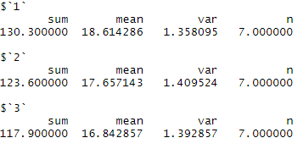

> tmpfn(z)



**Analysis of variance table**

> data=data.frame(z=z,group=factor(group))

> fit=lm(z~group,data)

> anova(fit)

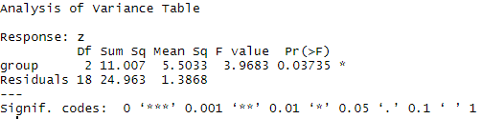

**The anova(fit) object can be used for other computations the tables F values can be found by the following.First we extract the treatment and error degrees of freedom.the we use qt to get the tabled F values.**

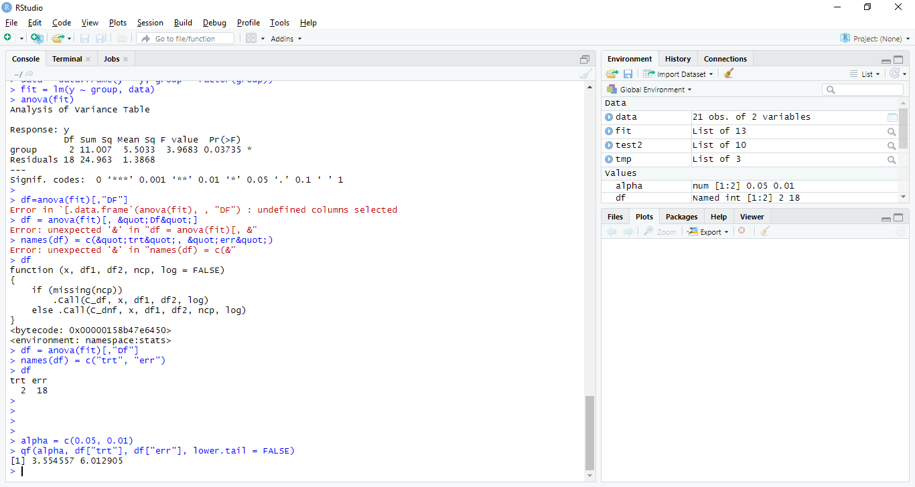

**A confidence interval on the pooled variance can be computed as well using the anova(fit)**

**object. First we get the residual sum of squares, SSTrt, then we divide by the appropriate chi-**

**square tabled values**.

